**Name:** Latin-Daucus carota, Wild Carrot, Queen Anne’s Lace(refers to the lacy white flower potentially traced back to St. Anne, patron saint of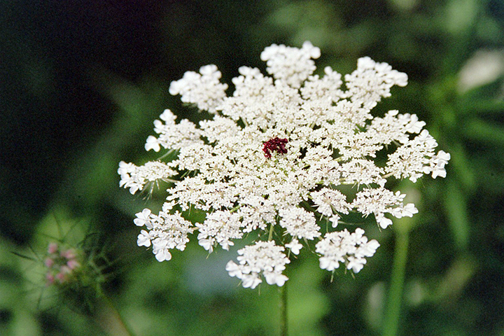 lacemakers and the midwife of St. Mary or Queen Anne who was the only monarch who ever ruled the American colonies in the 18th century or Anne Boleyn where the blog red droplets in the center is where they cut off her head while the white part corresponds with the big white collar worn during that era), Bee’s Nest, Bird’s Nest, Philtron

The genus name Daucus is thought to derive from the ancient Greek daubs, a name for members of the Umbelliferae family. The species and common name are thought to derive from the Greek name for the plant, karoton.

**Similarly Used Species:** B. bipinnata (gui zhen cao, nian shen cao), B. biternata, B. chinensis, B. parvif ora (xiao hua gui zhen cao) B. tripartite, B.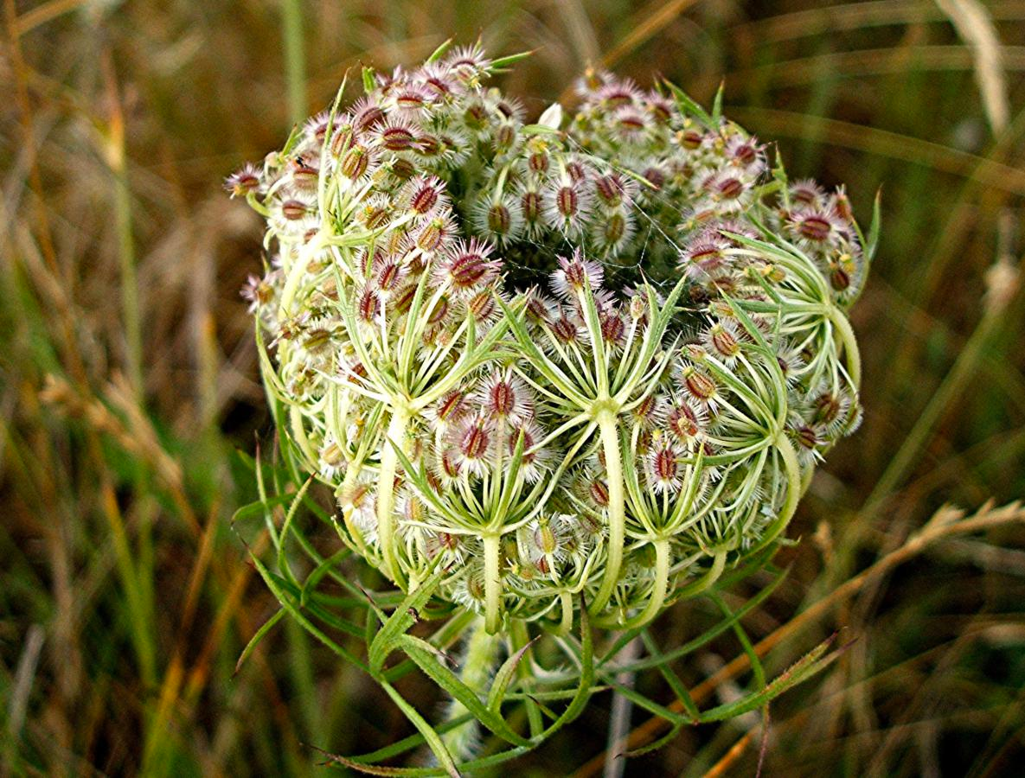 chilensis

**Family:** Apiaceae (Parsley Family)

**Location:** Native to Eurasia but widely naturalized

**Description:** A biennial that can grow up to 4 feet in height. The roots are white on the inside and brown on the outside and look like a carrot. Ribbed stems and aromatic, hermaphroditic, flowers that grow in flat topped umbels. The flower is white and lacy with a single drop in the center

**Growing Conditions:** Grows in heavy grasses where it is difficult for anything to penetrate the turf. Full sunlight.

**Parts Used:** Seed, Root & Leaf

**Uses:**

**Seed, root & leaf:** to strengthen the stomach, spleen, liver and lungs, bladder stones, cystitis, prostatitis, gallstones gout, indigestion, jaundice, kidney stones and parasites (thread worms)

**The seeds:** edema, flatulence, hangover and delayed menses. As a contraceptive it makes pregnancy difficult by making the endometrium lining slick so that the egg can not implant. Regulates the menstrual cycle, reduces heavy menstrual flow, reduces clotting during menstruation,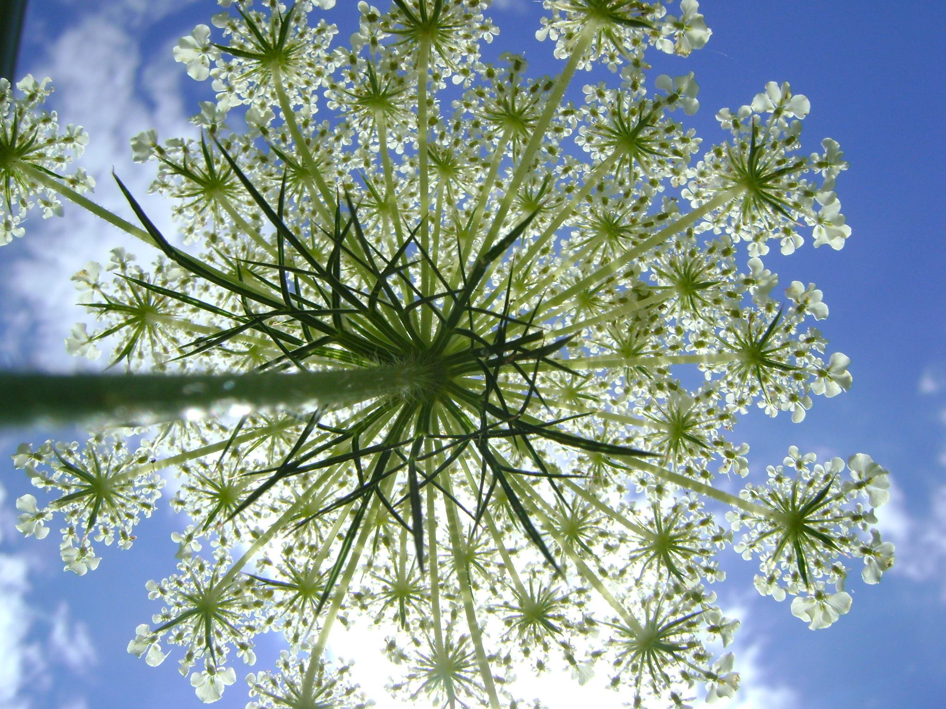 excessive growth of the uterine lining, and possibly endometriosis.

**Flower:** diabetes

**Root Juice:** the cleanse the liver (dilute it in water due to its sweetness) Cultivated edible: can be eaten fresh of cooked or dried or roasted and used as a coffee substitute. The flowers are also edible. The seeds are sometimes used as a condiment.

**Actions:**

**Seeds:** abortifacient, anthelmintic, astringent, carminative, contraceptive, deobstruent, diuretic, emmenagogue, galactagogue, lithotropic, ophthalmic, breaks up stagnant blood

**Root:** anthelmintic, antibacterial, astringent, carminative, deobstruent, diuretic, galactagogue, lithotriptic, liver tonic, ophthalmic, urinary antiseptic, antispasmodic, anti rheumatic

**Leaf**: anthelmintic, astringent, carminative, deobstruent, diuretic, galactagogue, lithotriptic, ophthalmic, antispasmodic, anti rheumatic

**Constituents:**

**Seed:** asarone, cartel, limonene, pinene

**Root:** carotene, pectin, alkaloids (daucine, asparagine), vitamin c, potassium

**Leaf:** flavonoids (kaempferol, quercitin), potassium, porphyrins

**Preparation/Dose:**

**Tincture:** 1-2ml 3 x a day (use Vodka not Brandy)

**Tea:** pour 1 cup of boiling water over 1 teaspoon over the dried arial parts or 1 tablespoon of the fresh arial parts and infuse for 10-15 minutes and drunk 3 x a day

**Seeds:** use as a contraceptive: please visit this website: http:// [wisewomanhealingways.com/articles/wild-carrot-exploration-final-](http://wisewomanhealingways.com/articles/wild-carrot-exploration-final-) summary-august-2011/

an infusion use 1/3 to 1 teaspoon of seeds to 1 cup of boiling water. Drunk 3 x a day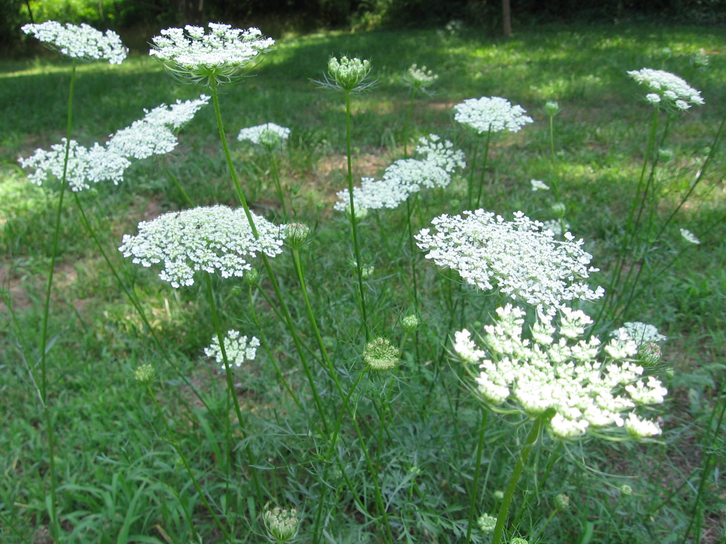

**Harvest:**

**Seeds:** in late summer before they turn brown

**Flowers:** Early to mid August before they go to seed

**Roots:** Fall

**Psychology:**

**Flower Essence:** Brings insight and groundedness, helps dispel persistent negative thoughts, and eases worry and anxiety. It is of particular benefit to those who close their eyes to reality.

**Combines:** Couchgrass, Bearberry, Buchu, Alfalfa

**Constitution:**

**Planet:** Venus, Mercury

**Element:** Fire

**Pulse:**

**Tongue:**

**Moisture:** moist

**Temperature:** warm

**Entering Meridians:**

**Contra-Indications:** avoid seeds during pregnancy. Carrots and their seeds can cause photosensitivity

**References:**

**The Book of Herbal Wisdom** by Matthew Wood

**Bartram’s Encyclopedia of Herbal Medicine**  by Thomas Bartram

**Medical Herbalism** by David Hoffman

**The Desktop Guide to Herbal Medicine** by Brigitte Mars

**http://wisewomanhealingways.com/articles/wild-carrot-exploration-final-summary-august-2011/**